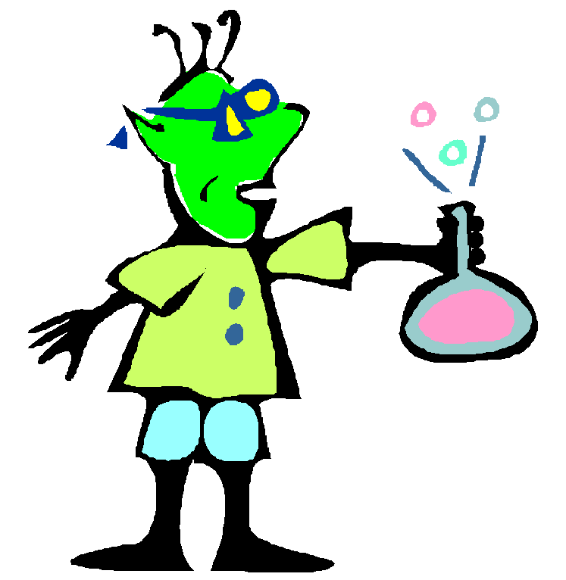

Physical Changes

A physical change occurs when a substance changes in some way but no

new substance is formed. When water is changed to a solid or a gas, the ice,

water and steam are different states of the same substance. As no new

substance is formed this change is known as a physical change. When a pencil

is sharpened another type of physical change takes place. Some of the wood

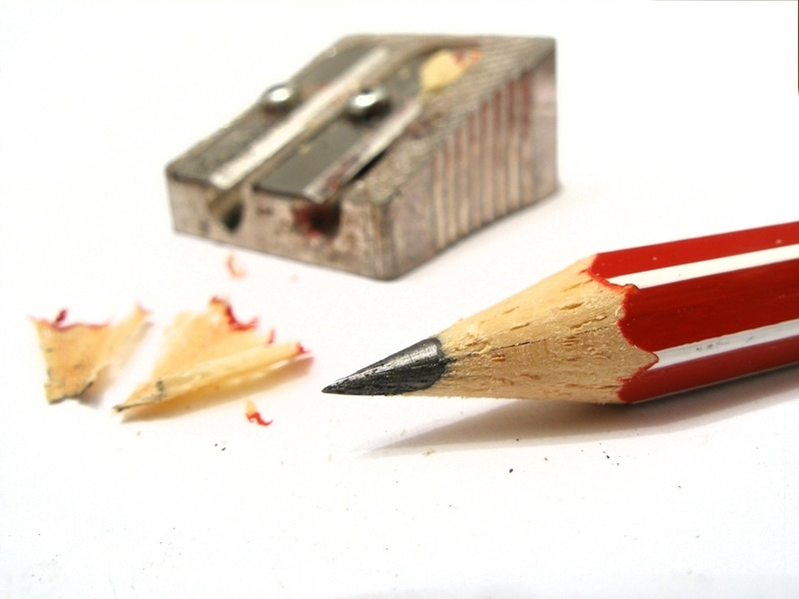
and graphite are changed to shavings. However, no new substance is formed.

Chemical Changes

A chemical change occurs when one or more substance changes to form one

or more new substances. At certain times of the year, people living near a

river or the sea complain about terrible smells that come from seaweed or

other dead matter washed up on the shore. The smell is due to these

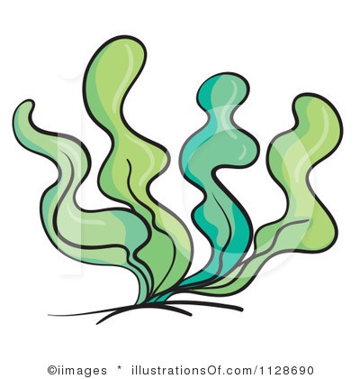
substances decaying. In the decaying process new substances are formed. A

chemical change has taken place.

